Name___________________________________

Quick Quiz

**Unit Rate 2**

Identify the unit rate:

1. 4 calculators cost $135 2. $y=5x$

**$_________ per calculator unit rate =_________**

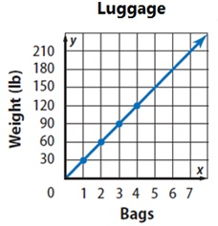

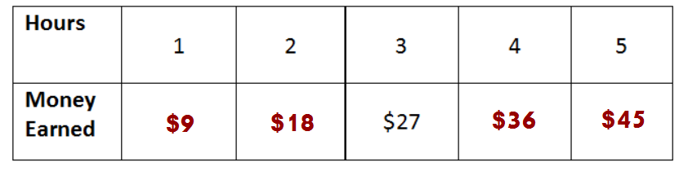3. 4.

**________**

**pounds per bag**

**$_________ per hour**

____________________________________________________________________________

Corrections

**Unit Rate 2**

Identify the unit rate:

1. 4 calculators cost $135 2.

**$_________ per calculator unit rate =_________**



3. 4.

**________**

**pounds per bag**

**$_________ per hour**